Professional Business Card

# Introduction:

1.1 Overview

I Design a professional business card using canva. It is best to think of a business card as a small piece of marketing that you can give to any existing or potential customer. Business card also communicate a sense of sercuity to the recipient , showing that you are a part of an established business that is ready and willing to work together. Canva is very easy way to use any templetates regarding business cards and anyone can use it without any obstacles.

1.2 Purpose

My project is creating a professional business cards. I create a professional business cards using in this canva. A business card is a highly personal form of marketing, and does exactly what you need it to. Business cards serve the key purpose of marketing your business and getting your key contact information into your client's hands… all in a matter of seconds. Fundamental to the value of the business card, is its portability.

2.Problems Definition & Design Thinking

2.1 Empathy map

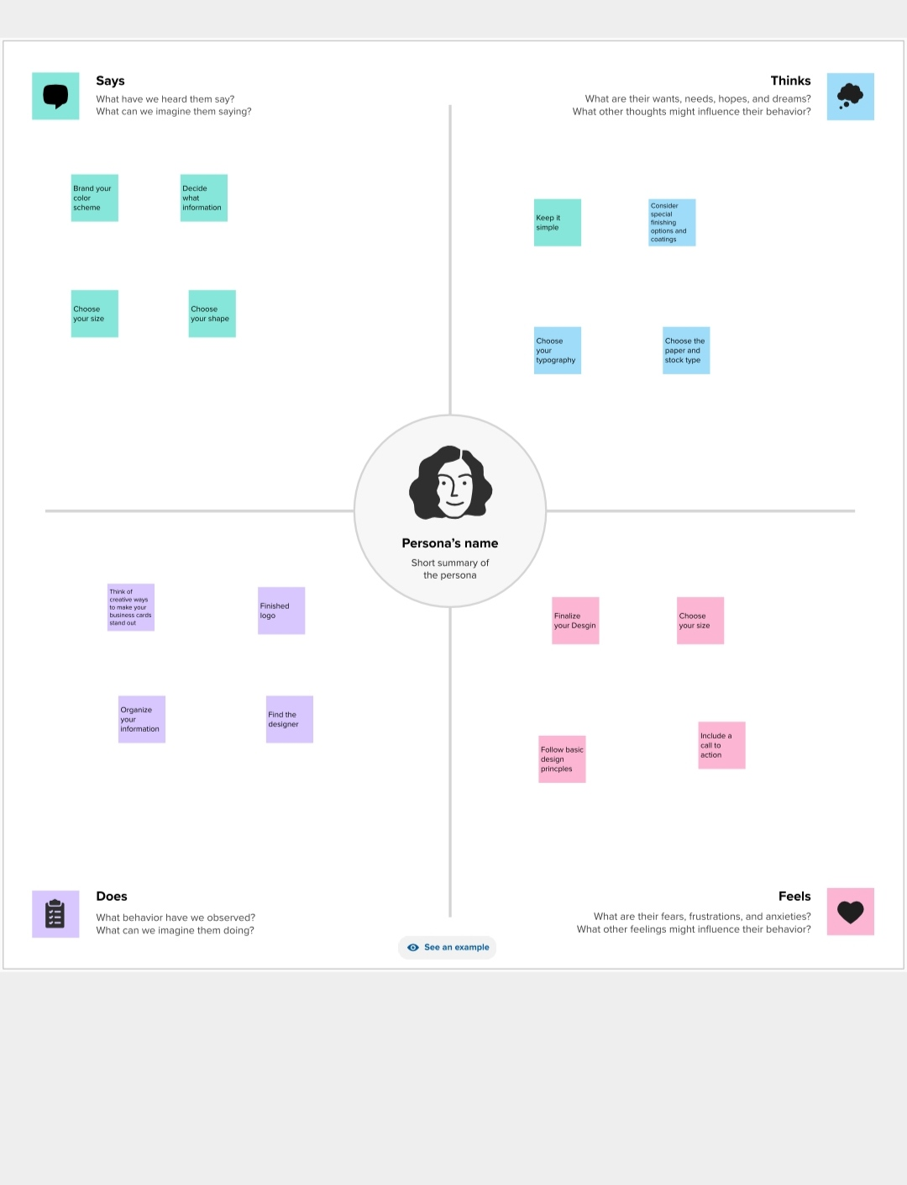

2.2 Brain Storm And Idea prioritization

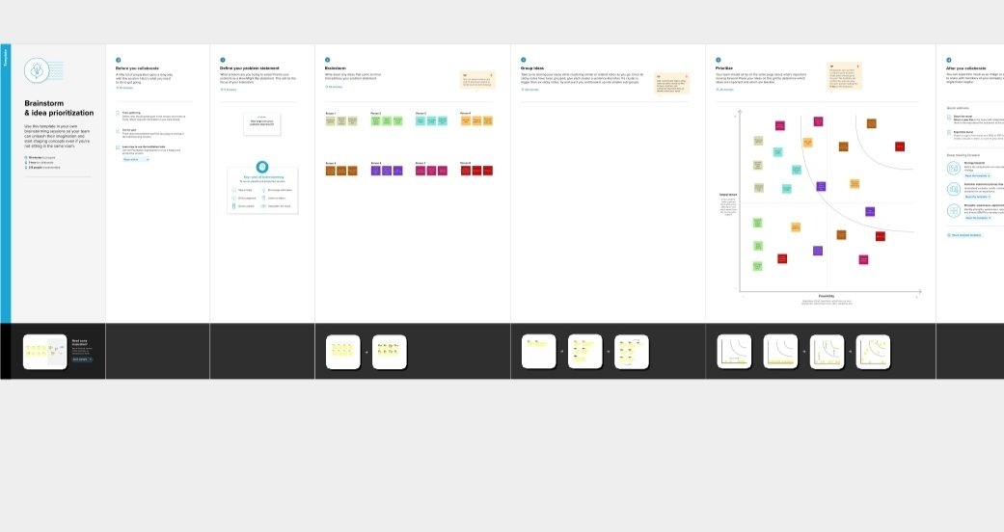

RESULT

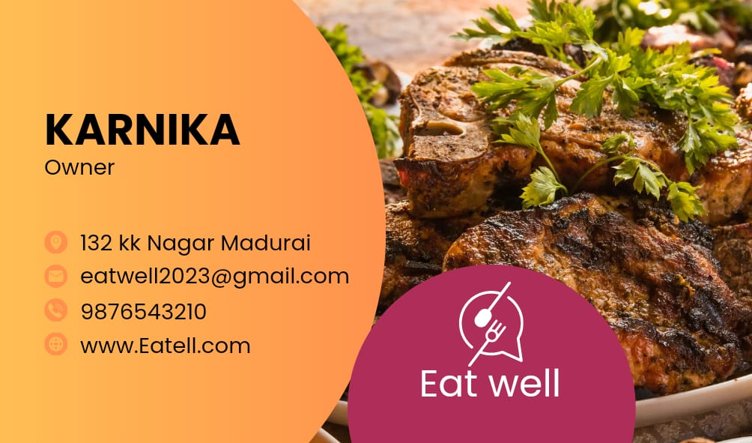

4. Advantages And Disadvantages

●Easy to using this canva

●Freshers easy to design anything in this canva

●In this canva has many templates

●Canva was very useful to everyone

5. Conclusion

We easily finish my project visually appealing certificate for a debate. Canva is the most useful and best app for the freshers. Because that the has many templates that was easy to use.